Word Count Application in Scala
SprakCount.txt file
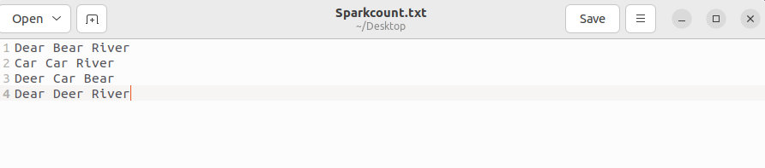

Step-1: Start the spark shell by going into the directory and use command ./spark-shell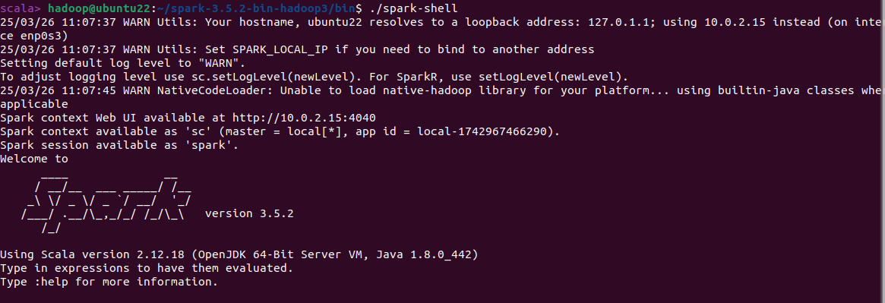
Step-2
- Open the text file to count words and store in rdd1
- Split based on “ “ using flatMap function
- Go through each word and assign count 1 using map function
- Use reduceByKey to get the total counts for every word
- Convert to df to display total counts 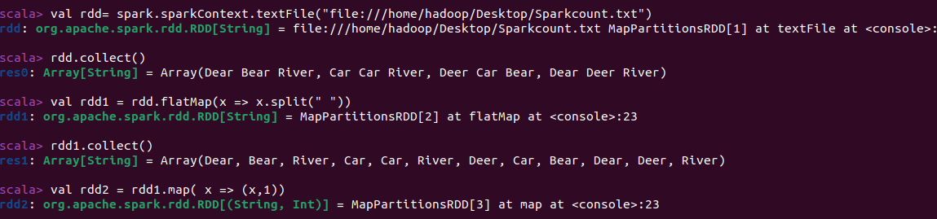
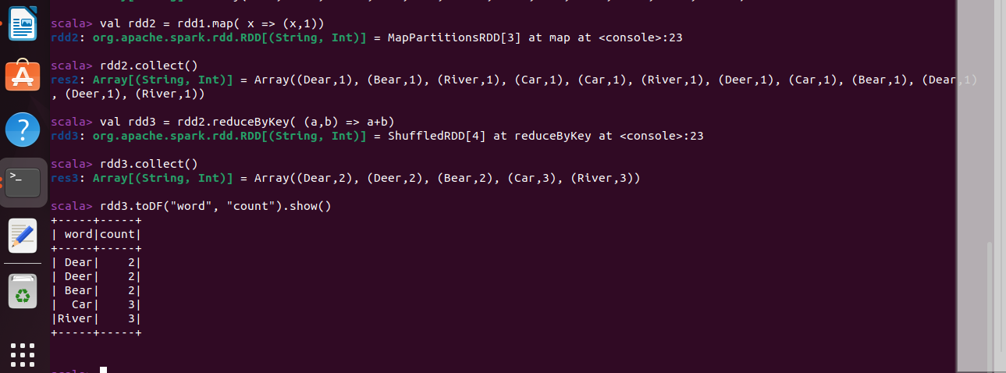

In Pyspark
Step-1: Open pyspark console using ./pyspark
